**Project Planning Phase**

**Project Planning Template (Product Backlog, Sprint Planning, Stories, Story points)**

|  |  |
| --- | --- |
| Date | 15 February 2025 |
| Team ID | LTVIP2025TMID21141 |
| Project Name | Edu Tutor AI: Personalized Learning With Generative AI and LMS Integration |
| Maximum Marks | 5 Marks |

**Product Backlog, Sprint Schedule, and Estimation (4 Marks)**

Use the below template to create product backlog and sprint schedule

| **Sprint** | **Functional Requirement (Epic)** | **User Story Number** | **User Story / Task** | **Story Points** | **Priority** | **Team Members** |
| --- | --- | --- | --- | --- | --- | --- |
| Sprint-1 | Registration | USN-1 | As a user, I can register for the application by entering my email, password, and confirming my password. | 2 | High | Mathineni Karthik |
| Sprint-1 | Quiz Generation (AI) | USN-2 | As a user, I will receive confirmation email once I have registered for the application | 1 | High | Mathineni Karthik |
| Sprint-2 | Social Login | USN-3 | As a user, I can register for the application through Facebook | 2 | Low | Mikkili Viswas Abhishikth |
| Sprint-1 | Social Login | USN-4 | As a user, I can register for the application through Gmail | 2 | Medium | Mullapudi Sowmya Bharathi |
| Sprint-1 | Login | USN-5 | As a user, I can log into the application by entering email & password | 1 | High | Meesala Sai |
| Sprint-2 | Dashboard | USN-6 | As a student, I can view my quiz results and progress in a dashboard | 3 | High | Mullapudi Sowmya Bharathi |
| Sprintt-2 | Dashboard | USN-7 | As a teacher, I can track student performance and download reports | 3 | Medium | Meesala Sai,Abhishikth |

**Project Tracker, Velocity & Burndown Chart: (4 Marks)**

| **Sprint** | **Total Story Points** | **Duration** | **Sprint Start Date** | **Sprint End Date (Planned)** | **Story Points Completed (as on Planned End Date)** | **Sprint Release Date (Actual)** |
| --- | --- | --- | --- | --- | --- | --- |
| Sprint-1 | 20 | 6 Days | 24 Oct 2022 | 29 Oct 2022 | 20 | 29 Oct 2022 |
| Sprint-2 | 20 | 6 Days | 31 Oct 2022 | 05 Nov 2022 | 19 | 06 July 2025 |
| Sprint-3 | 20 | 6 Days | 07 Nov 2022 | 12 Nov 2022 | 18 | 13 July 2025 |
| Sprint-4 | 20 | 6 Days | 14 Nov 2022 | 19 Nov 2022 | 20 | 20 July 2025 |
|  |  |  |  |  |  |  |
|  |  |  |  |  |  |  |
|  |  |  |  |  |  |  |
|  |  |  |  |  |  |  |

**Velocity:**

Imagine we have a 10-day sprint duration, and the velocity of the team is 20 (points per sprint). Let’s calculate the team’s average velocity (AV) per iteration unit (story points per day)



Average velocity (AV) =

Total Completed Story Points across 4 Sprints÷Total Days=(20+19+18+20)÷(4×6)=77÷24≈3.21 story points per day

**Team’s average velocity = 3.21 story points/day**

**Burndown Chart:**

A burn down chart is a graphical representation of work left to do versus time. It is often used in agile[software development](https://www.visual-paradigm.com/scrum/what-is-agile-software-development/) methodologies such as [Scrum](https://www.visual-paradigm.com/scrum/scrum-in-3-minutes/). However, burn down charts can be applied to any project containing measurable progress over time.

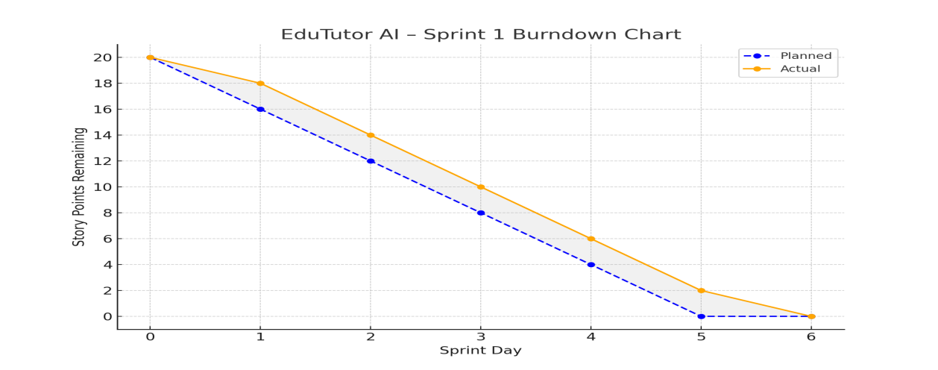

### 📉 ****Sprint 1 – Burndown Chart (Description)****

The **Sprint 1 Burndown Chart** visualizes the reduction in story points over the 6-day sprint. It shows both the **Planned** and **Actual** progress lines:

The **Planned line** assumes a steady daily completion of work (linear decline).

The **Actual line** reflects the real pace of the team.

The team successfully **completed all 20 story points** by Day 6, aligning well with the planned schedule.

Minor lag on Days 1 and 2 was quickly recovered, indicating good sprint management and coordination.

This chart demonstrates that the team worked consistently and maintained velocity, successfully achieving sprint goals.

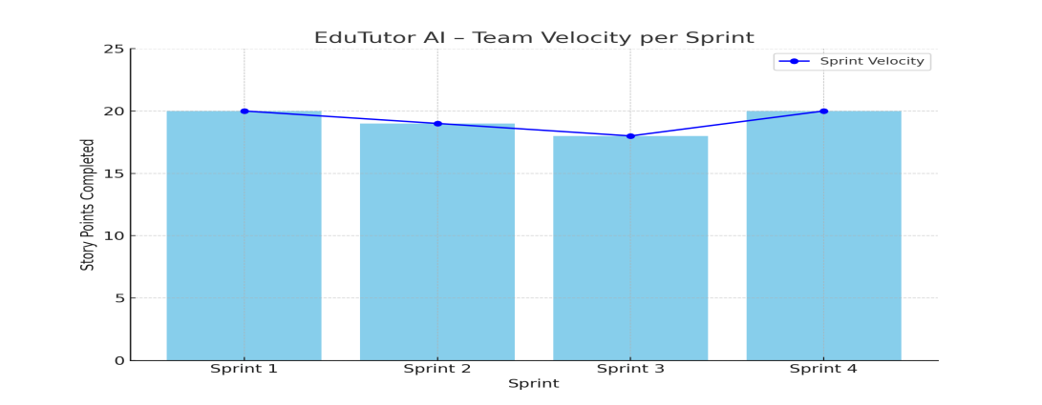

### ****Sprint Velocity Chart – Sprint 1 to 4 (Description)****

The **Velocity Chart** shows the number of story points completed in each sprint across four consecutive sprints:

**Sprint 1:** 20 points

**Sprint 2:** 19 points

**Sprint 3:** 18 points

**Sprint 4:** 20 points

This trend indicates:

A consistently high performance across all sprints.

Slight dip in Sprints 2 and 3 due to minor delays or additional complexity.

Full recovery in Sprint 4, showing adaptability and improved collaboration.

The **average team velocity** is **19.25 story points per sprint**, which is a strong indicator of steady and reliable progress.